Step 1: -first go to the Jenkins-> go to the manage Jenkins->select manage plugins

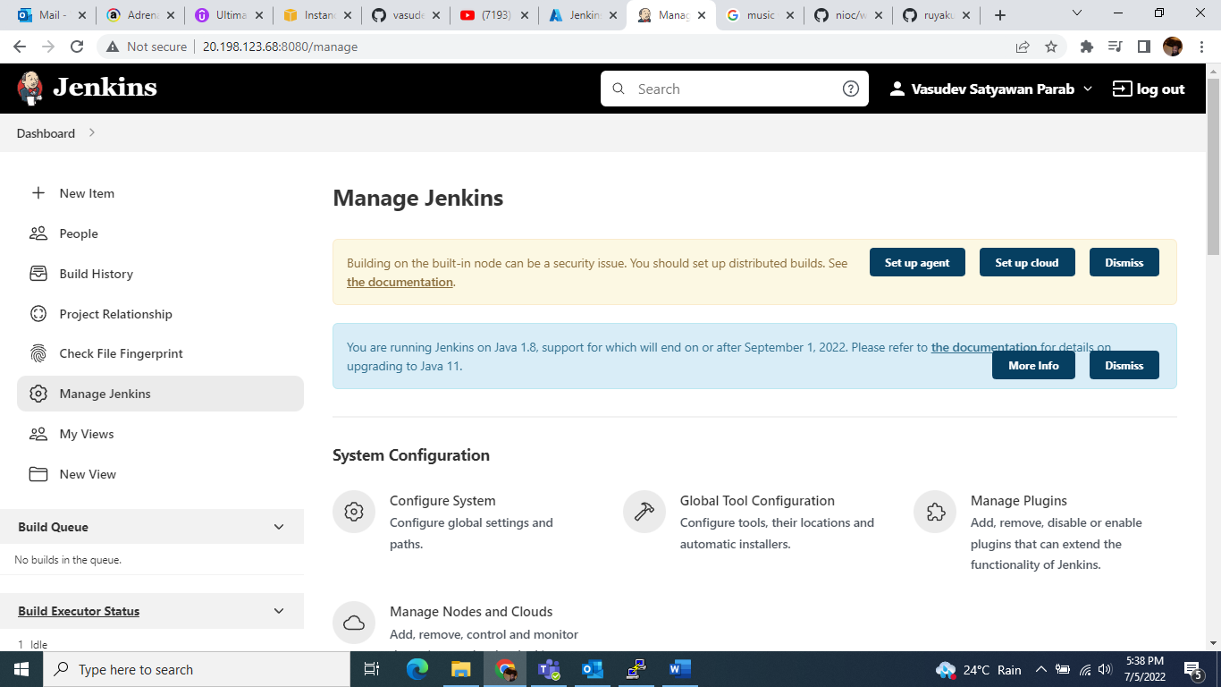

Step2 :- click on “Available” option and write “maven integration plugin”…….

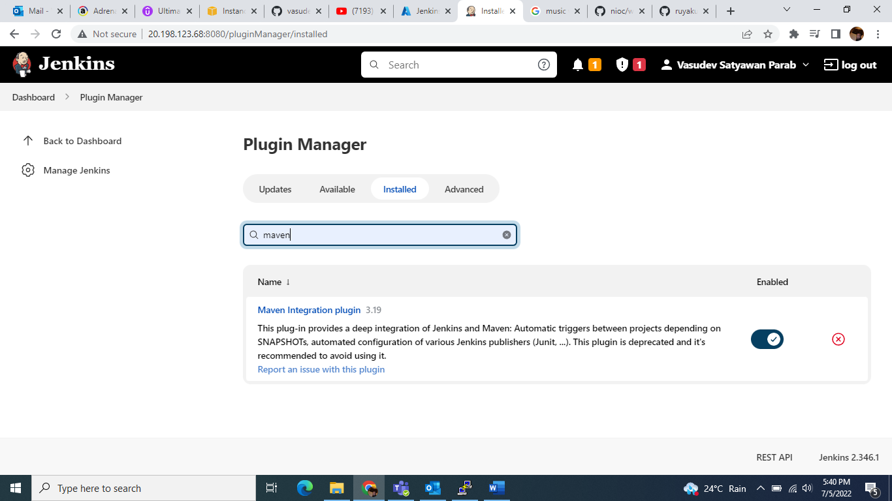

Step 3: - then select “install without restart”…..

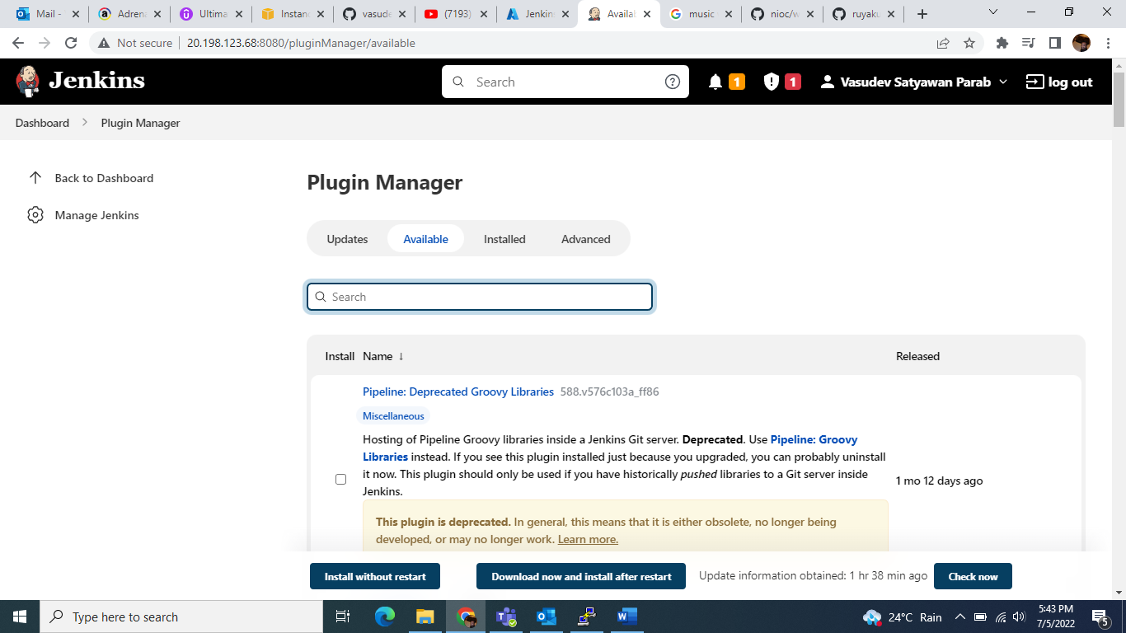

Step 4 :- next go to the Jenkins Dashboard and create new job select option “new item”

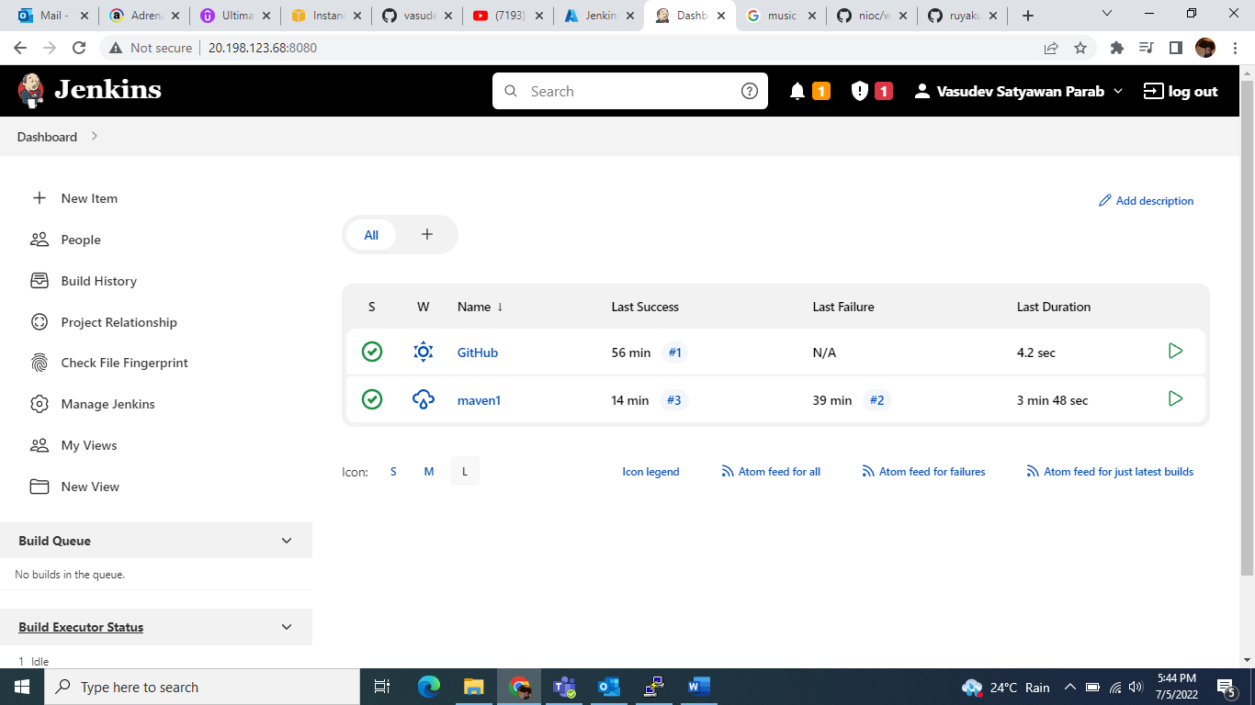

Step 5 :- go to the “source code management” select “Git” option and put the “GitHub Repository URL” and also “add credential”……..

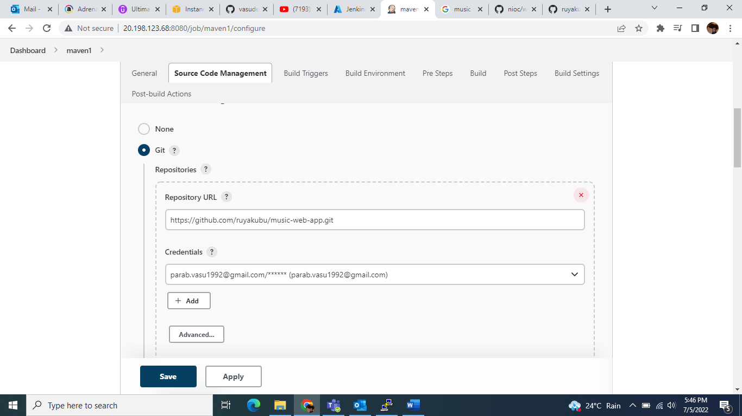

Step 6 :- next select branch “for example master”

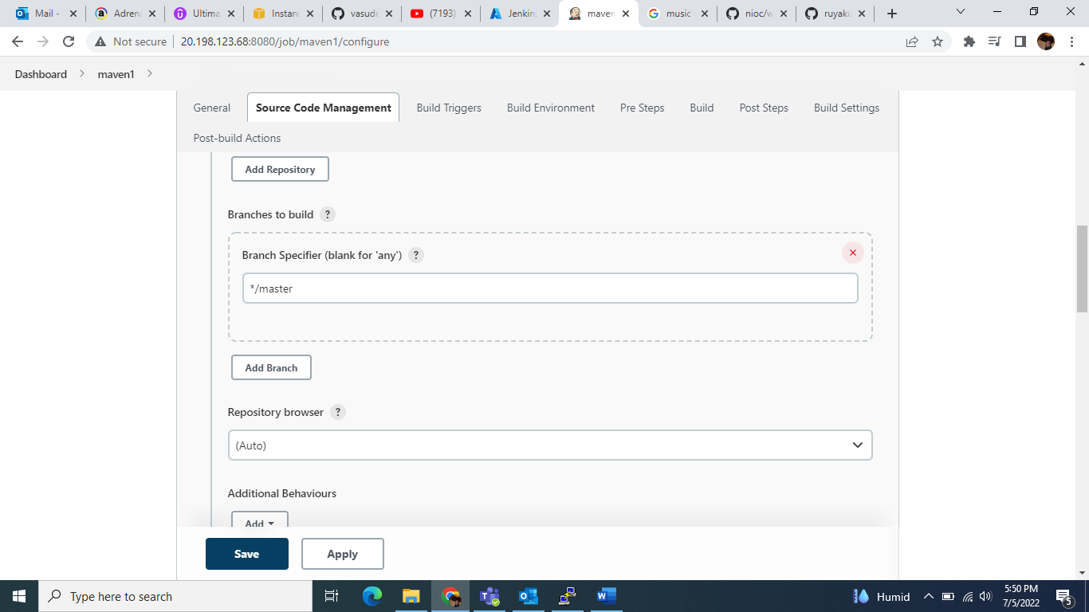

Step 7:- next go to the “Build” and select Root pom “pom.xml” and Goals and options “clean install”……

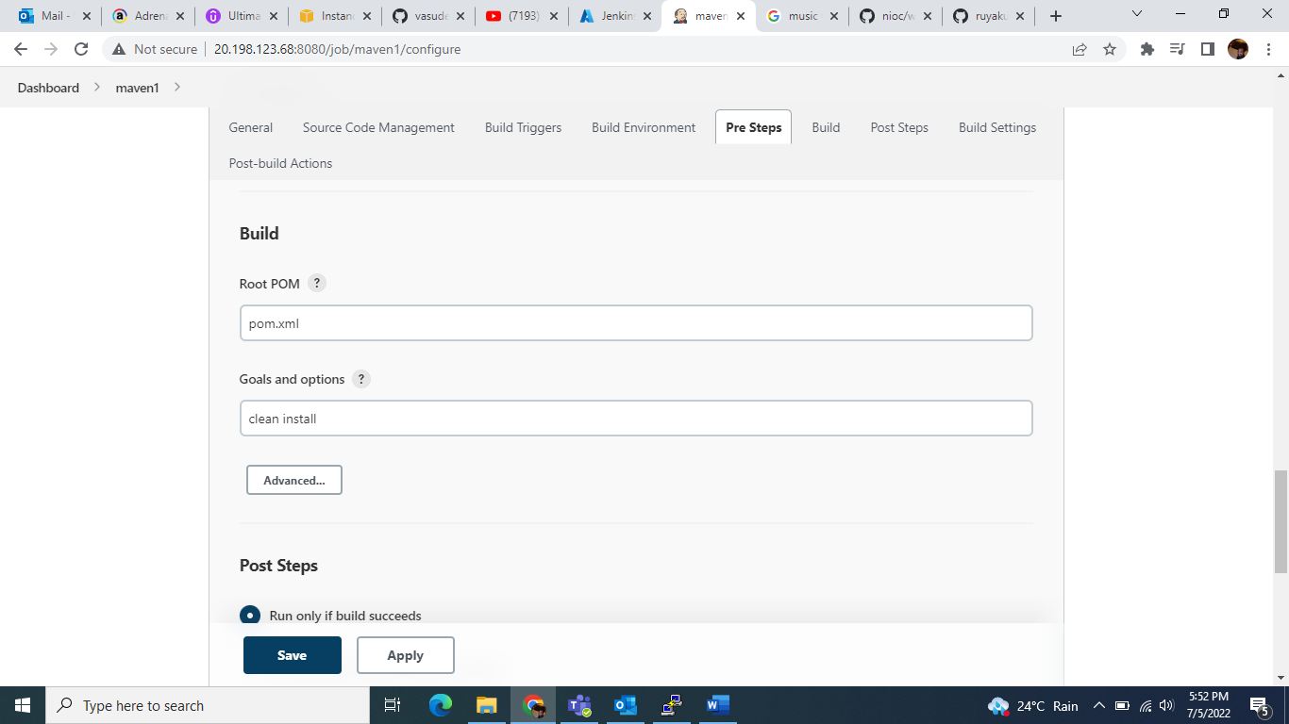

Step 8:- next go to the post steps select “Run only if build succeeds” then last click on “Apply” and “Save”……

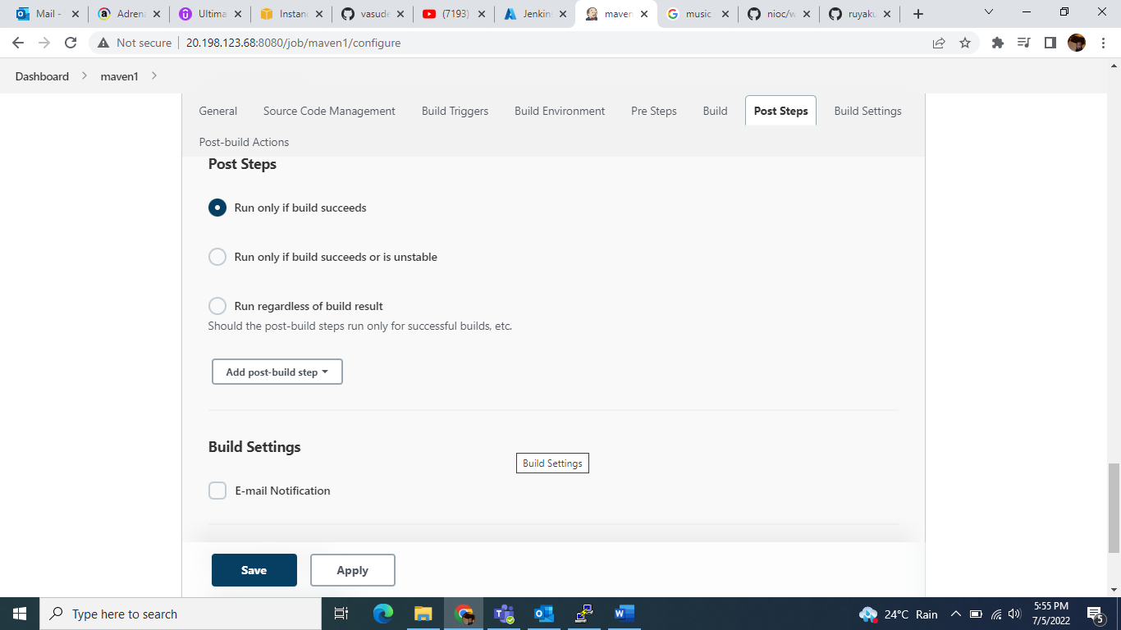

Step 9 :- click on “Build now” option…..

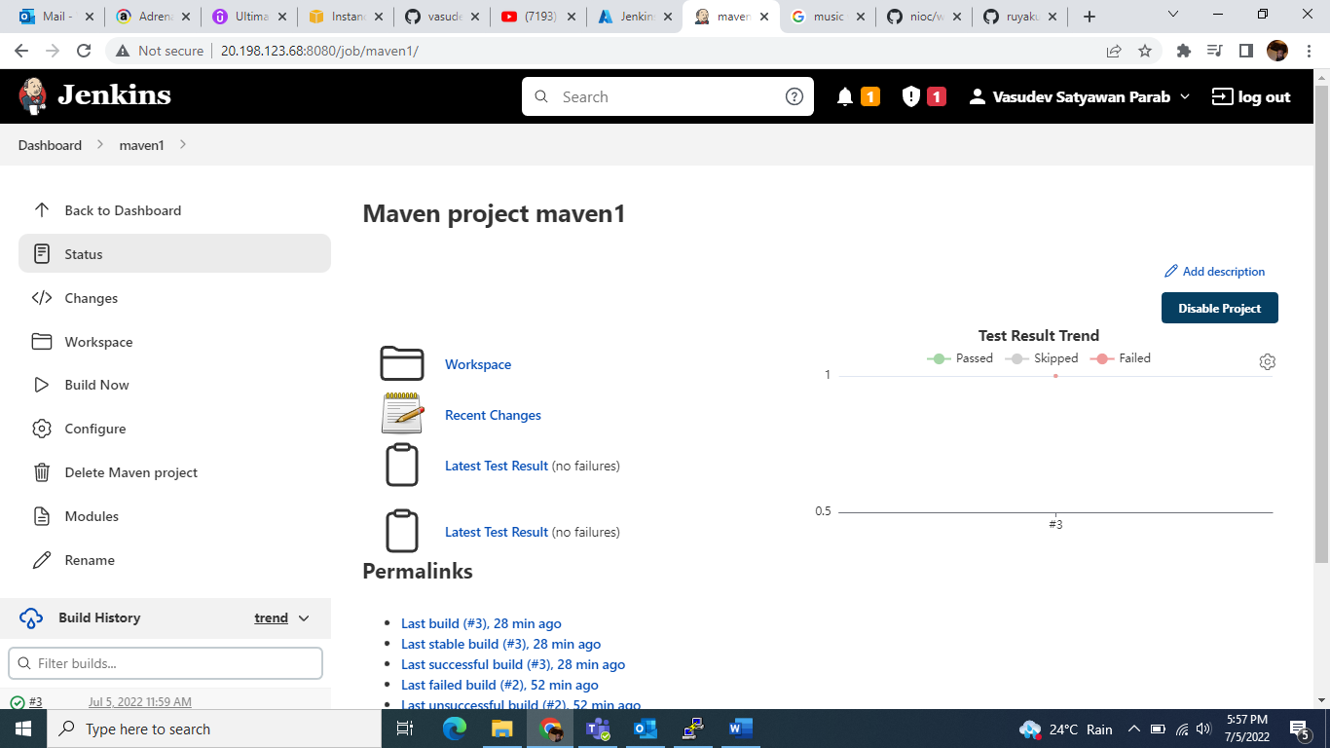

Step 10:- then go to the bottom left side check “Build History”……

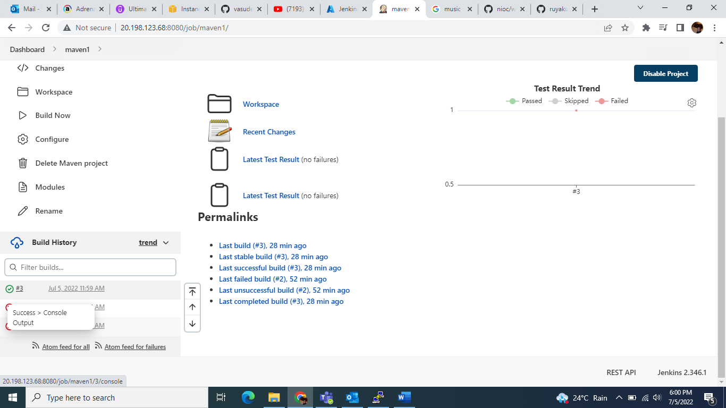

Step 11 :- next click on “console output”……

